EXPERIMENT NO:31

Design PDA using simulator to accept the input string anbn

AIM:  To design PDA using simulator to accept the input string anbn

INPUT:

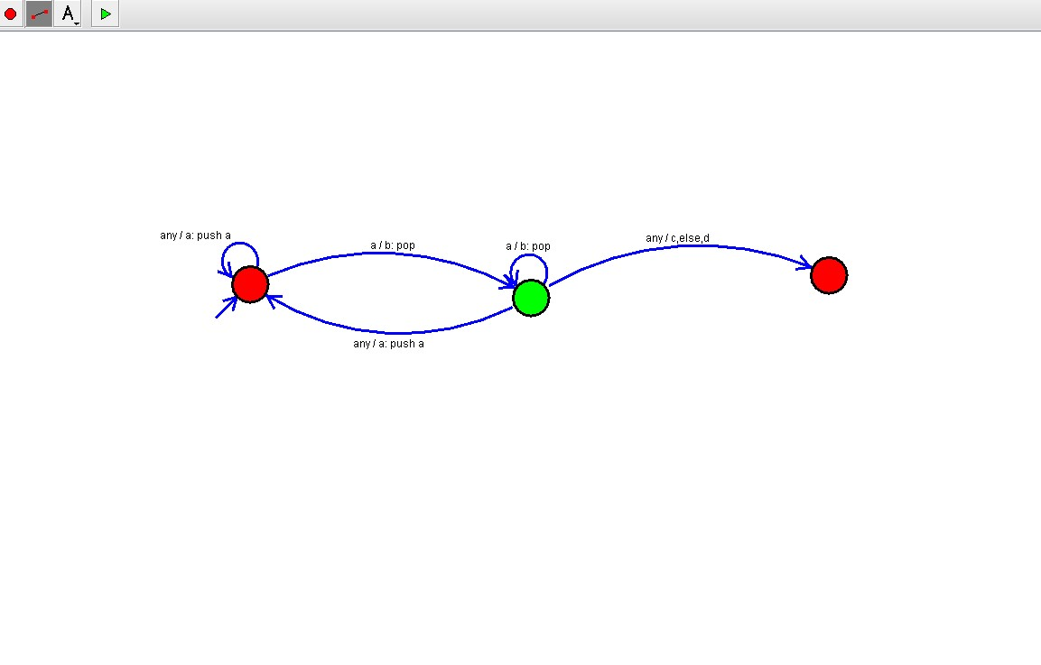

OUTPUT:



RESULT: The program executed successfully and got output.